Appendix 1.

**Using inter-point distance based *R*2 to measure multivariate heritability.**

Measuring the community level effects of genetic variance presents two main challenges. The first is that communities are inherently multi-dimensional. Thus, species can be responding in complex ways to the effect of genetic variation, similar to correlated traits in complex phenotypes. The second is that species’ abundances tend to not be normally distributed, making standard parametric statistical methods invalid due to violations of important data distribution assumptions. In the community genetics literature, methods have primarily followed the methods of Shuster et al. 2006, which employs ordination to produce a low dimensional representation (usually a vector) of the variation in the community using an NMDS (Non-metric Multi-Dimensional Scaling) approach using Bray-Curtis dissimilarity to handle the data distribution assumptions.

In the main body of the manuscript we use the inter-point distance method of Anderson 2001 to calculate the multivariate *R*2 for the effect of tree genotype on community composition. This methods addresses both the issue of multi-dimensionality and the non-normal distribution of species abundances. Like the Shuster et al. 2006 method, it uses Bray-Curtis dissimilarity; however, it has the advantage of not reducing the variation in the community through dimensionality reduction. Thus, the inter-point distance (IPD) *R*2 should be a more robust measure of the community level effect of genetic variance, as it takes into account the full variation present in the community, and should perform better as a measure of community heritability (HC2).

Indeed, comparing the NMDS and IPD methods for measuring HC2 we find that the IPD method is much more consistent than NMDS when calculated for the simulated communities (Fig. 1). We therefore use this metric throughout the study when measure HC2.

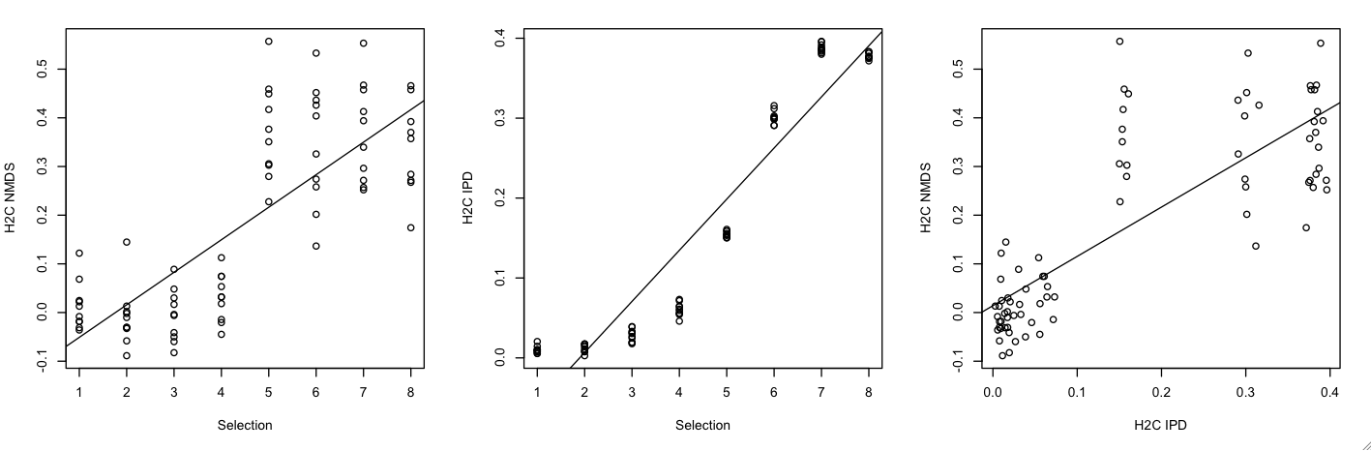

**Figure 1.** Three panel figure showing the relationship between selection and the two community heritability metrics (H2C NMDS and H2C IPD) and the relationship between the two metrics themselves.